Mug Shot Implementation Guide

Photographic Considerations Related to Facial Recognition Software
and Booking Station Mug Shots
There is a wide range of problems common to mug shots that can interfere with the effectiveness of facial recognition software. These problems generally involve a combination of four factors: camera, background, lighting, and subject posing. While a better camera can produce an immediate improvement in image resolution, if the other three factors are not addressed it is unlikely that the usefulness of the photos will be changed significantly.
The purpose of this document is to help you make simple changes to your booking station environment and photography techniques that will substantially improve the quality of your mug shots. These suggestions involve the use of readily available materials and a minimum of effort and expense.

Background
Background problems fall into two categories:
- Background brightness and color
- Background obstructions
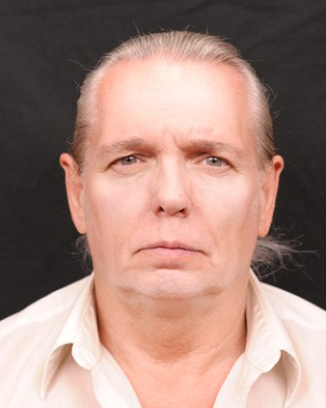
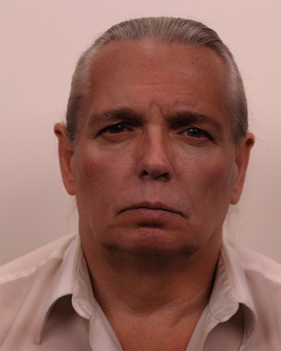
  - Automatic exposure functions on cameras analyze the brightness value (luminosity) of objects in a photograph and average those levels to achieve a proper exposure setting on the camera. A solid black background in a mug shot could result in the subject’s facial features being overexposed and washed out. A solid white background could result in the subject’s facial features being underexposed and dark.
Photography companies have established a specific shade of gray as the ideal luminosity for proper exposure. It is identified as 18% reflectance gray. A few examples of paint that are reasonably close include: Benjamin Moore 2132-40, Sherwin Williams SW 7074, Glidden GLN46, Behr UL260-4, Olympic D58-4, and Valspar 4005-2A. The exact duplication of this shade is not critical; however, it does need to be gray to avoid interfering with the automatic color settings on your digital camera. Also, it should have a matte finish to avoid glare.
The other background consideration involves having shapes in the photograph that facial recognition software may mistake for facial features.
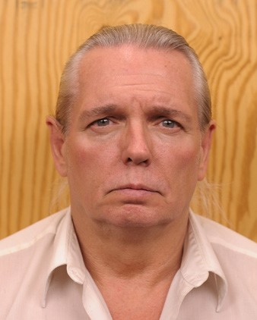
These sometimes include: wood grain, cinder blocks, wallpaper, shadows, texture, height charts, and mirrors. In order for facial recognition software to “find” the face, the background should be completely smooth and featureless.
  - These photographs are not actual mug shots and the person depicted
for educational and training purposes only. therein has no criminal history. These photographs are being utilized Revised 4/25/13
If the wall that you are using for a mug shot background is already smooth, then it can be painted with the previously mentioned paint. If it is not smooth, an easy remedy is to paint a 4’x4’ sheet of lumber and mount it permanently to the wall. A heavy primer may be necessary to cover the texture of the grain and knots in the wood.

Lighting
The auto exposure capabilities of today’s digital cameras and a gray background should provide for exposure considerations when taking booking photos. However, steps still need to be taken to correct problems with the intensity and harshness of the light, as well as the location of the light source.
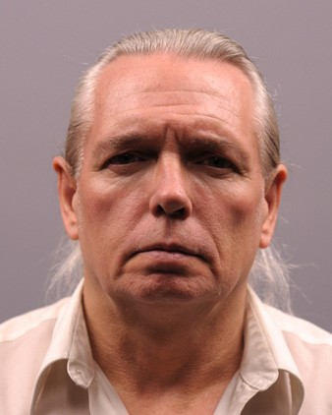
While many consumer-grade cameras can take recognizable photographs in low light, the sharpness of the picture can be severely degraded due to light amplification features of the camera or motion blur.
Lights placed too directly overhead or uneven, harsh light sources can cast shadows on the face and background that obscure facial characteristics and interfere with facial recognition software. On-camera flash creates problems with red-eye and background shadows.
All of these lighting considerations can be easily remedied by installing dedicated light fixtures readily available at any national hardware store or possibly already available at your location.

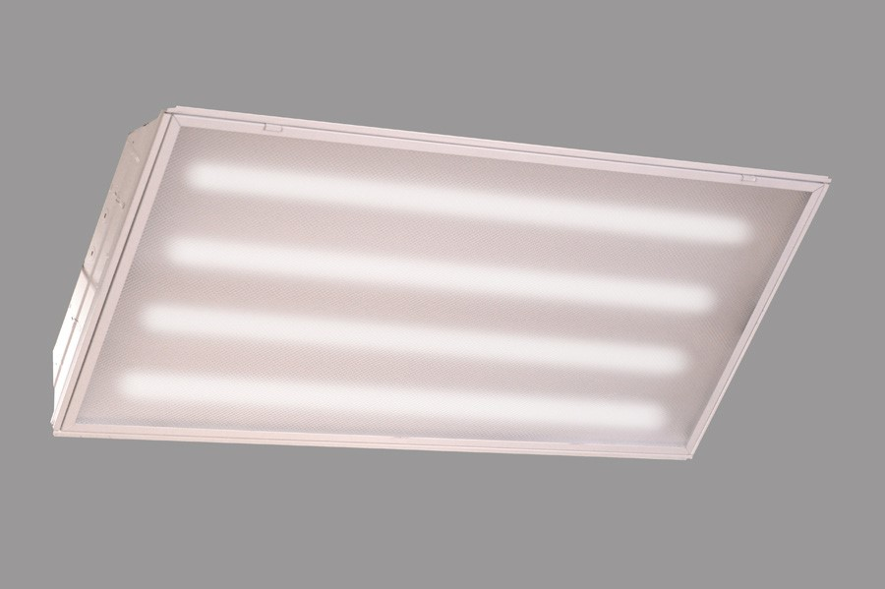
Four-bulb, four-foot long, fluorescent lighting fixtures are commonly available and usually sell for less than $50.00 each. Two of these fixtures can be hung in front of your booking photograph location. Combined, they should provide sufficient light to reduce problems with low-light underexposure and picture sharpness. Because of their size and light diffusing covers, the problems of harshness and shadows should be eliminated on both the face of the subject and the background.
Detailed specifications for collecting facial recognition images in an ideal environment can be found in a document titled, “Capture and Equipment Assessment for Face Recognition Systems” on the Facial Identification Scientific Working Group (FISWG) website at www.fiswg.org.
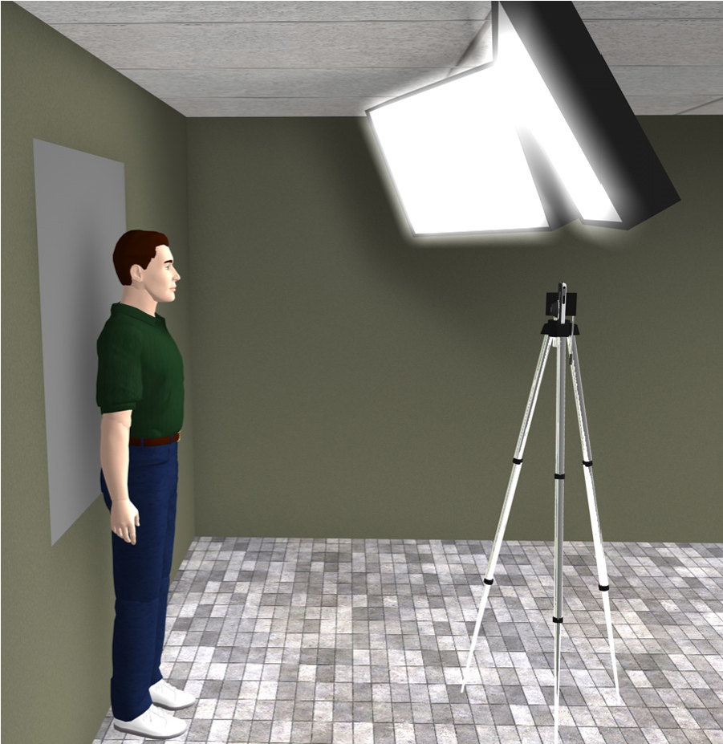
On a typical eight-foot ceiling, these fixtures should be hung about five feet in front of your photographic background. They should be angled downward at about 45 degrees and inward to get the maximum light on the face of the person being photographed.
It is strongly advised that these light fixtures be professionally installed according to local building codes and in a manner that will preclude the possibility of injury.

Subject Posing
It is important for the purpose of facial recognition that the person being photographed is looking directly at the camera with their full face and ears exposed and without any facial expression. Tilting or rotating of the head can cause inaccurate facial measurements that may result in recognition problems. Several common errors are addressed in the attached document, “Your Mug Shots Should Look Much Like This.” This document serves as a quick reference and can be printed and permanently displayed in view of the person taking the mug shots.
